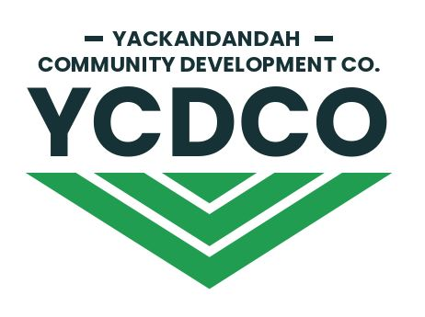

Transfer Notice
(Proposal to sell shares)

Please lodge this Transfer Notice with the Yackandandah Community Development Company Ltd, PO Box 188, Yackandandah 3749 or email to ycdco.secretary@yackandandah.com

- I apply to transfer (sell) (number) Shares (“Subject Shares”) at the (“Transfer Price”) as set
outlined in rule 29 of the YCDCo Constitution.

- Proposing Transferor

Title from Share Certificate

- By lodging this Transfer Notice, I agree to be bound by the Constitution of the Company and declare that all statements made by me are complete and accurate.
Authorised Signatory Name

Signature

Date

Our Administration and Finance Manager may request further information from you to ascertain true ownership and transfer rights.

Contact details
Contact Name
Physical Address
Contact email
Contact phone
Account for payment
Account Name
BSB
Account Number

We respect your rights to privacy under the Privacy Act 1988 (Cth) (the Act) and we comply with all of the Act’s requirements in respect of the collection, management and disclosure of your personal information. Personal information will only be used for its intended purpose.

