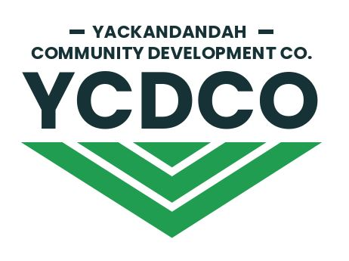

The YCDCo Board is a voluntary one, responsible to shareholders for the conduct of YCDCo’s businesses.The Corporations Act 2001, ASIC rules and regulations, various State and Federal legislation and YCDCo’s Constitution and policy documents, regulate the conduct of the Board of Directors. Further, the Board of YCDCo seeks to hold and maintain the trust of its shareholders and the Yackandandah community. Potential directors should make themselves familiar with the general regulatory and operating environment of the Board. More information is available from https://ycdco.com.au/

NOMINEE CONTACT INFORMATION

Name
Postal Address
Ph/ Mob | Ph | Mob
email

Please use more space if required.
Question One. Are you involved in other community organisations in Yackandandah?

Question Two. Other than monthly Board meetings, what level of time will you be able to offer a Board role?

Question Three. What motivates you as a volunteer?

Question Four. What expectations do you have of the Board of YCDCo?

Question Five. What aspirations do you have as a Director of YCDCo?

Question Six. What practical skills and experience do you bring to a Director’s role?

Question Seven. Please describe any potential conflicts of interest you might have as a Director of the YCDCo Board?

Please include a brief c.v. when submitting your expression of interest.

Please print this form and sign.

Nominee Signature |  | Date

Please provide the names and contact phone numbers of two referees.

Referee Name |  | Contact  Number

Referee Name |  | Contact  Number

Expressions of Interest in becoming a member of the Board of Directors of YCDCo may be forwarded by email to ycdco@yackandandah.com
Please contact Ian Fitzpatrick on 0419 418 236 if you have any questions.

