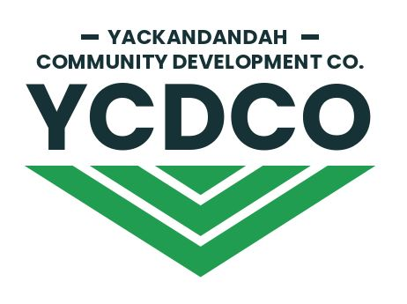

Offer Notice
(Proposal to buy shares)

Please lodge this Offer Notice with the Yackandandah Community Development Company Ltd, PO Box 188, Yackandandah 3749 or email to ycdco.secretary@yackandandah.com

- I/We apply to purchase (number) Shares (“Subject Shares”) at (“Transfer Price”) as set outlined in rule 29 of the YCDCo Constitution.
$332
Total payable
$

- Title for Share Register
See Note Overleaf

Applicant’s Name/s | Surname/Company Name | Given name/ACN
1.
2.
3.

- I am an existing shareholder of YCDCo YES/NO
I am a resident of Yackandandah (within 20 km of the Yackandandah Post Office YES/NO

D Address

Street address
Postal address
Town/City
State and Postcode

E Contact details

Contact name
Mobile number
Home number
Contact email

F Bank Account details – for dividend payments

Account Name
Bank
BSB
Account number

G Tax file numbers
I/We apply this/these tax file numbers or exemptions to all my/our investments in the Company

Applicant name | TFN
1.
2.
3.

H Declaration

By lodging this Offer Notice I/We declare that this Application is completed and lodged according to the notes below and agree to be bound by the Constitution of the Company and the terms and conditions of the Offer and that all statements made by us are true and accurate

Name | Signature | Date
1.
2.
3.

Notes

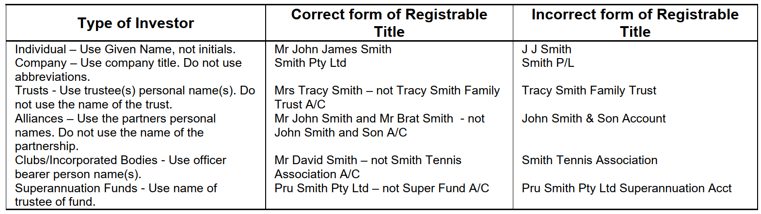

Instructions to Applicants

1. Insert the number of Shares you wish to apply for and the total amount payable

2. The minimum number of Shares is one.

3. Applications must be in the name(s) of natural person(s), companies or other legal entities acceptable to the Company up to a maximum of three names per application. For a guide, please refer to the table on Page 2.

4. Please enter your postal address, phone and contact details. Usual correspondence will be via email unless indicated otherwise

5. Please provide us with telephone numbers (including the person responsible in the case of an application by a company) so that we can contact you quickly if there is an irregularity in your Application Form. If you have any questions on how to complete this Offer Notice please contact the Share Registry on 0448 803 411 or at ycdco.secretary@yackandandah.com

6. The Applicant(s) agrees that this application is for Shares in the Company upon and subject to the terms set out in the Constitution. The Applicant(s) declares that all details and statements made by me/us are complete and accurate.

7. Once your application has been accepted by the Board, we will contact you with details on how to pay for the shares.

8. TAX FILE NUMBERS (‘TFN’) are authorised by tax law and the Privacy Act. The failure to quote a TFN will not invalidate your application for Shares.

9. LODGEMENT OF APPLICATIONS: Please post or deliver the completed Application Form to the following address:

The Company Secretary
Yackandandah Community Development Company Ltd
PO Box 188
YACKANDANDAH VIC 3749 or email the completed form to ycdco.secretary@yackandandah.com

We respect your rights to privacy under the Privacy Act 1988 (Cth) (the Act) and we comply with all of the Act’s requirements in respect of the collection, management and disclosure of your personal information. Personal information will only be used for its intended purpose.

